TRIBHUVAN UNIVERSITY

**PATAN MULTIPLE CAMPUS**

PATAN DHOKA, LALITPUR

**DIGITAL LOGIC (BIT 103)**

**LAB 2**

|  |  |
| --- | --- |
| **SUBMITTED BY** | **SUBMITTED TO** |
|  |  |
| NAME: SURESH DAHAL | JYOTI PRAKASH CHAUDHARY |
| CLASS: BIT – I / I |  |
| ROLL NO: 23 | ………………………… |
| DATE: 2080/10/07 | CHECKED BY |

**TITLE: REALIZE THE GIVEN BOOLEAN FUNCTIONS WITH LOGIC DIAGRAM AND TRUTH TABLE**

1. **F1 = X’YZ + XY’Z + X’Y’Z’ + XZ’**
2. **OBJECTIVE**

* To realize the given Boolean function with logic diagram and truth table.
* To practically observe the output of given function on different input values.

1. **REQUIREMENTS**
   * 1. Digital Learning Kit and Simulator
     2. 3 NOT gates, 3 three inputs AND gates, 1 two input AND gate and 1 four input OR gates.
     3. Connecting wires
     4. Interactive / Sequence generator as input
     5. LED as output
2. **THEORY**
   * + 1. **INTRODUCTION**

In this lab, we are going to realize the given Boolean function using NOT, AND, and OR gates to practically observe its output for different input values. The given function represents a logical function involving three input variables: X, Y, and Z. It is a "sum of products" representation, where each term represents a product of inputs and the entire expression is a sum of these products.

* + - 1. **LOGIC EXPRESSION**

F1 = X’YZ + XY’Z + X’Y’Z’ + XZ’

* + - 1. **CIRCUIT DIAGRAM**

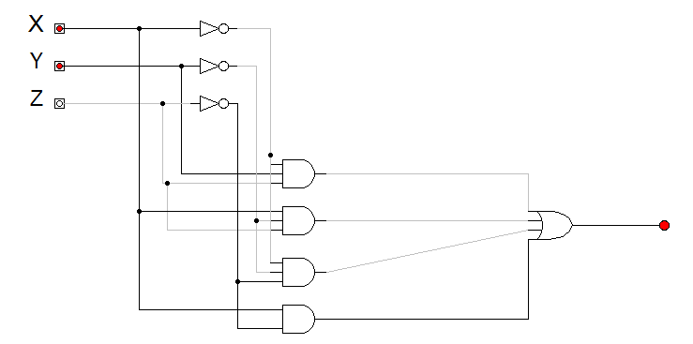

**F1**

* + - 1. **TRUTH TABLE**

|  |  |  |  |
| --- | --- | --- | --- |
| X | Y | Z | OUTPUT (F1) |
| 0 | 0 | 0 | 1 |
| 0 | 0 | 1 | 0 |
| 0 | 1 | 0 | 0 |
| 0 | 1 | 1 | 1 |
| 1 | 0 | 0 | 1 |
| 1 | 0 | 1 | 1 |
| 1 | 1 | 0 | 1 |
| 1 | 1 | 1 | 0 |

1. **CONCLUSION**

Hence, by doing this practical experiment, we have realized the given Boolean function using different logic gates. We have observed that the given function produced a low output (0) specifically when the input values, arranged in the order of x, y, and z, were 001, 010, and 111. In all other input combinations, the circuit generated a high output (1).

1. **F2 = (W’ + X’ + Y)’ . Z**
2. **OBJECTIVE**

* To realize the given Boolean function with logic diagram and truth table.
* To practically observe the output of given function on different input values.

1. **REQUIREMENTS**
   * 1. Digital Learning Kit and Simulator
     2. 2 NOT gates, 1 two input AND gate, and 1 three input OR gate.
     3. Connecting wires
     4. Interactive / Sequence generator as input
     5. LED as output
2. **THEORY**
   * + 1. **INTRODUCTION**

In this lab, we are going to realize the given Boolean function using NOT, AND, and OR gates with different inputs to practically observe its output for different input values. The given function represents a logical function involving four input variables: W, X, Y, and Z. It is a "product of sum" representation, where sum of three variables are multiplied with another variable.

* + - 1. **LOGIC EXPRESSION**

F2 = (W’ + X’ + Y)’ . Z

* + - 1. **CIRCUIT DIAGRAM**

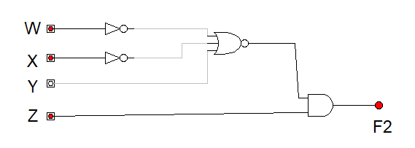

* + - 1. **TRUTH TABLE**

|  |  |  |  |  |
| --- | --- | --- | --- | --- |
| W | X | Y | Z | OUTPUT (F2) |
| 0 | 0 | 0 | 0 | 0 |
| 0 | 0 | 0 | 1 | 0 |
| 0 | 0 | 1 | 0 | 0 |
| 0 | 0 | 1 | 1 | 0 |
| 0 | 1 | 0 | 0 | 0 |
| 0 | 1 | 0 | 1 | 0 |
| 0 | 1 | 1 | 0 | 0 |
| 0 | 1 | 1 | 1 | 0 |
| 1 | 0 | 0 | 0 | 0 |
| 1 | 0 | 0 | 1 | 0 |
| 1 | 0 | 1 | 0 | 0 |
| 1 | 0 | 1 | 1 | 0 |
| 1 | 1 | 0 | 0 | 0 |
| 1 | 1 | 0 | 1 | 1 |
| 1 | 1 | 1 | 0 | 0 |
| 1 | 1 | 1 | 1 | 0 |

1. **CONCLUSION**

Hence, by doing this practical experiment, we realized the given Boolean function using different logic gates. We have observed that the given function produced a high output (1) specifically when the input value, arranged in the order of w, x, y, and z, were 1101. In all other input combinations, the circuit generated a low output (0).